AP Calc AB Name: _______________

______________ _____________

WS Assessment

Target 18:

Selecting techniques

For antidifferentiation

**I can:**

* Calculate an integral using other techniques

Unit 6: Integration and Accumulation of Change

HW Target 18 Unit 6

Using formula

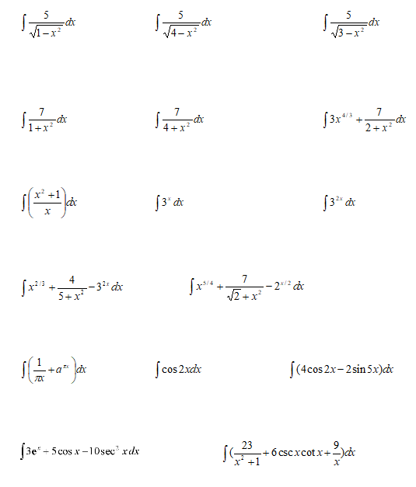

Review long division, partial fraction, complete the square

Split this: 21 – 4x – x2 = ( )( )

Split this: $\frac{x^{3}-4}{x^{2}-x-2}$

Do integral





$\int{\frac{x^{3}-4}{x^{2}-x-2} dx}$ $\int{\frac{dx}{21-4x-x^{2}}}$

**Assessment Target 18**